Have used this code to create a class for pigudf included pig jar

package pig_problem;
import java.io.IOException;
import java.util.Iterator;
import java.util.Map;
import org.apache.pig.Algebraic;
import org.apache.pig.EvalFunc;
import org.apache.pig.backend.executionengine.ExecException;
import org.apache.pig.data.DataBag;
import org.apache.pig.data.Tuple;
import org.apache.pig.data.TupleFactory;
public class Bpl_Percentage extends EvalFunc<Integer>{
@Override
public Integer exec(Tuple input) throws IOException {
// TODO Auto-generated method stub]
if(input.size()==0)
return 0 ;
try{
int perc = (Integer)input.get(0);
int value = 180;
int res = perc*(value/100);
return res;
}catch(Exception e){
throw new IOException("caught exception processing");
}
}

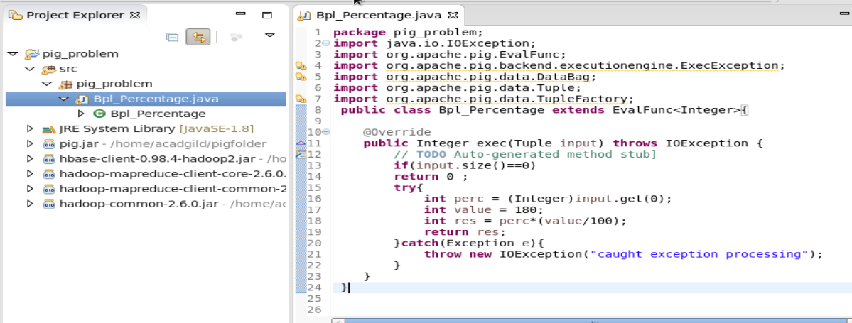
After that export nd created a jar
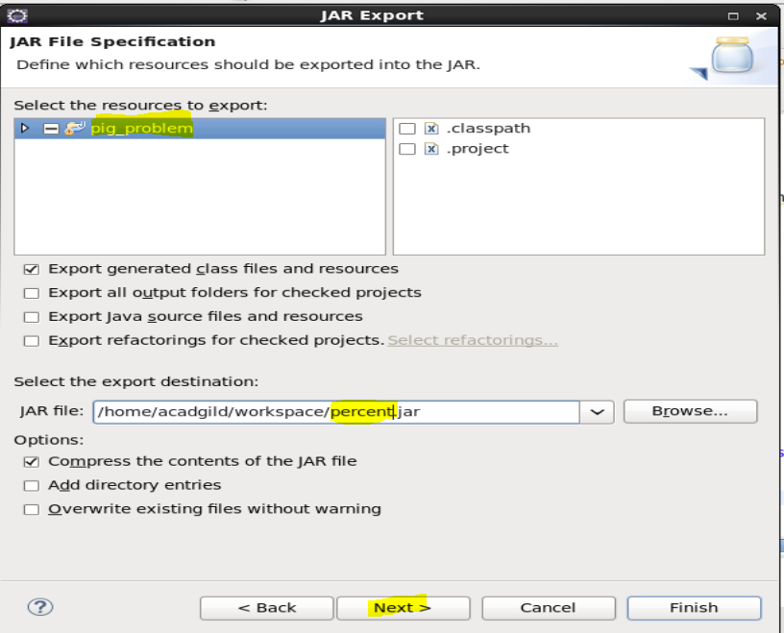 after that register the jar in local pig shell
Pig –x local
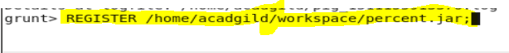
After that define the xpath
And define the jar using name as percentage
After that trying to load the content of xml file present in local.
Then generating the filed from that in B
After that using jar function in C

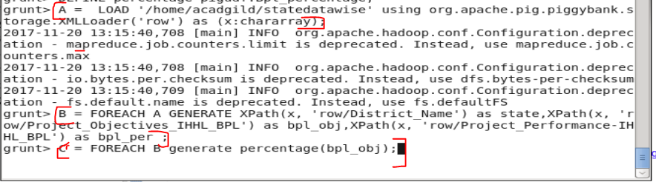

But it is showing error for that so please help me
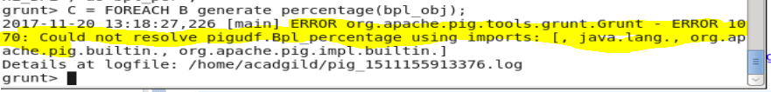that’s the error so help me oout
}

